Cart Assignment

1. When the page loads home page should display the items of default category in the dropdown i.e biryani

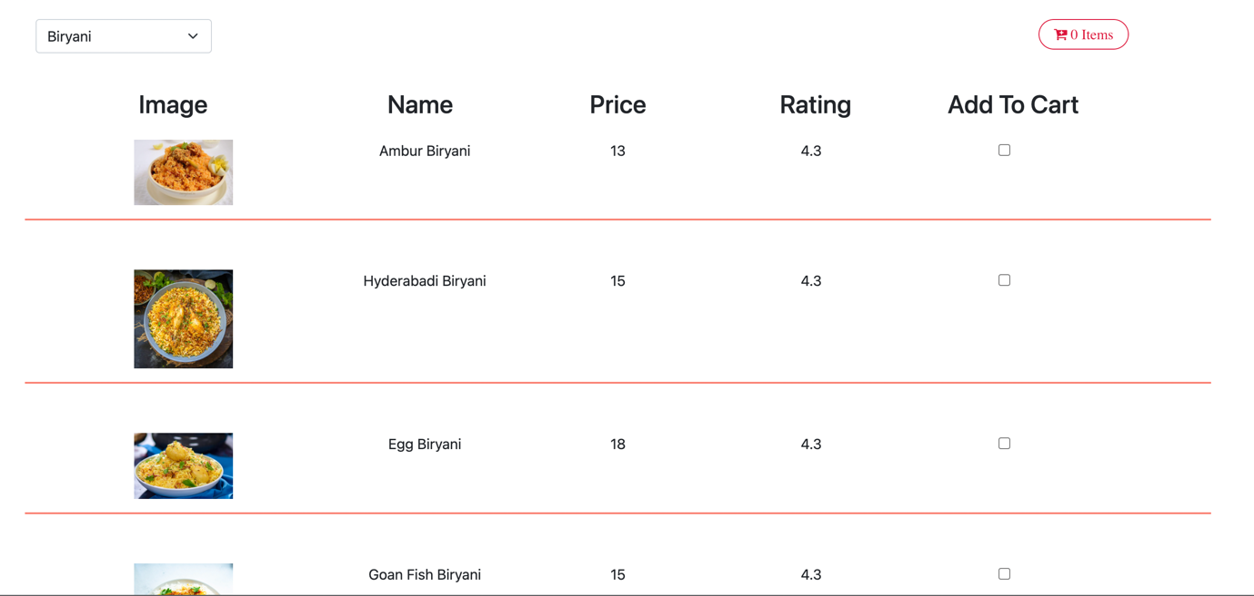

1. On selecting other category it should display respective items as follows:  
     
   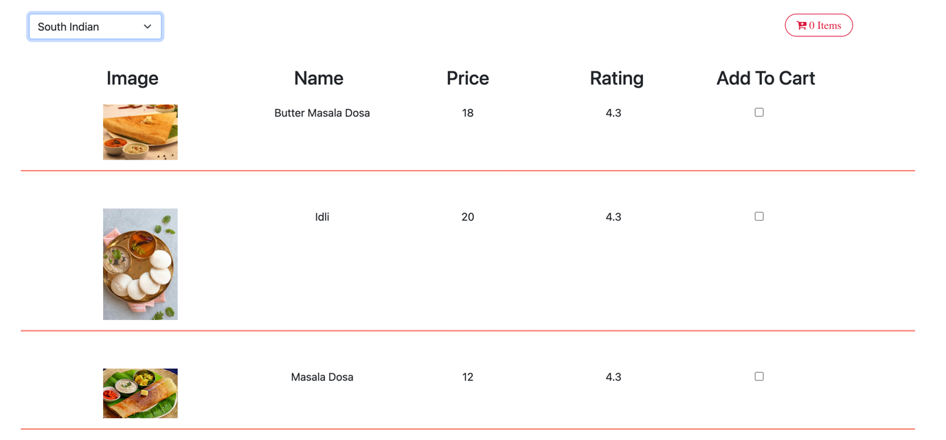
2. Once an item is selected it should update the Cart as follows:  
     
   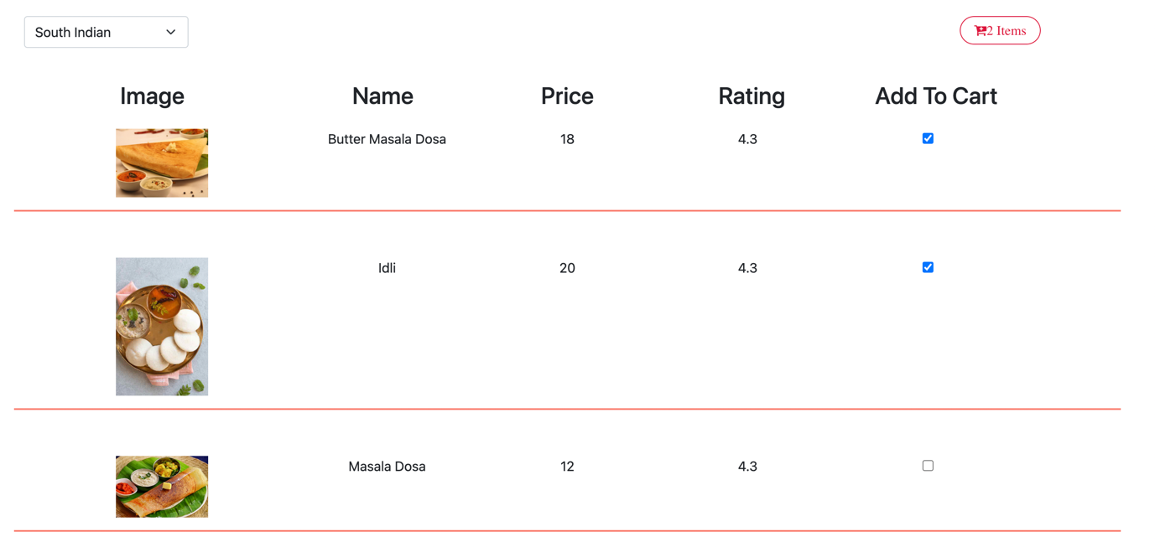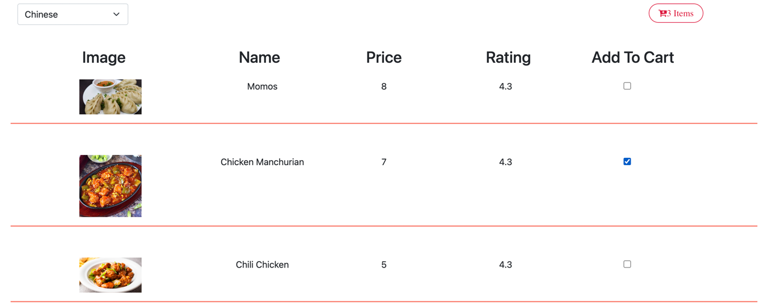
3. If the already added item is selected again it should display an alert “Item already added” and the checkbox should remain ticked  
     
   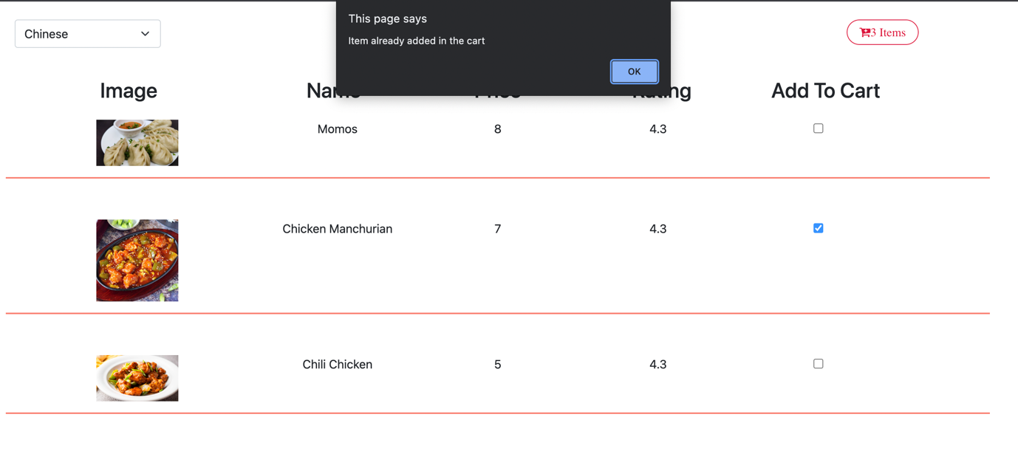

**ADVANCE**

1. Once the cart is clicked it should display UI as follows and ‘+’ ‘-‘ buttons should allow to increase and decrease the items , updating the prices accordingly  
     
   